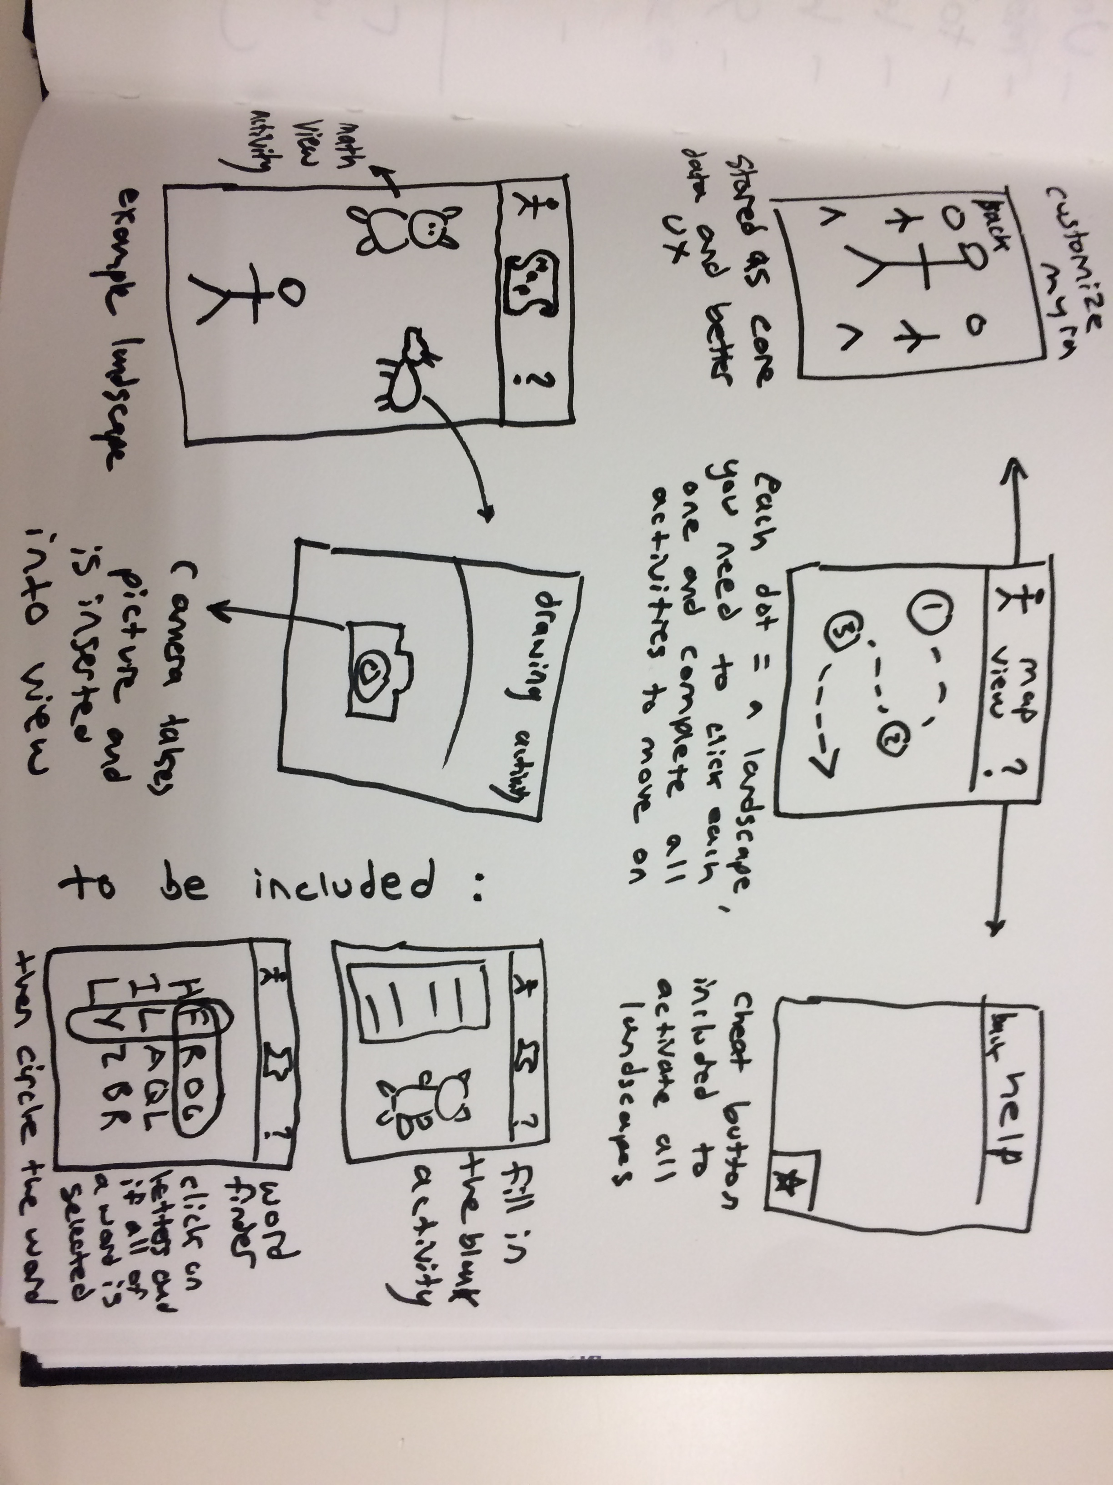 For the graduate project, I will be building out my first project such that it contains a main map scene with 3 different landscapes, each with its own activities. The data will be handled in a better manner with core data and there will be functionality to imbed pictures into the app.

The goal is similar to project 1, where I am turning some of the activities found in my coloring book into app form. Although the chronological nature of the story will not be included in the app, my goal is to make it fun and functional enough for children to experiment with. This will be an iOS app.